Therion III Post Flight Analysis
Author: Charlie Garcia
Drafted: June 29, 2016
Contents
1. Scope 2
1.1 Methodologies 2
1.2 Timeline 2
2. Propulsion 2
2.1 Premature Motor Cut Off 2
3. Avionics 4
3.1 Pyxida Arming Failure 4
3.2 Pyxida Remote Pyro Command Anomaly 4
3.3 TeleMetrum Telemetry Anomaly 4
3.4 StratoLogger CF-100 Power Loss at Landing 4
4 Recovery 5
4.1 Main Deployment Anomaly 5
4.2 Drogue Chute Gore Failure 7
4.3 Drogue Chute Swivel Deformation 8
5 Structures 8
5.1 Vehicle Roll Rate 8
5.2 Lithobreaking Exceeded Design Loads 9
6 Payload 9
6.1 Plasma Canard Detachment 9
6.2 OpenCV Data Collection Anomaly 11
6.3 Mobius Camera Overheating 11
7 Lessons Learned 11

Scope
This document will analyze the flight of Therion 3 at IREC 2016. The document will outline deviances from the expected flight profile and attempt to provide a mechanism for the deviances. These abnormalities will be discussed in roughly chronological order, by subsystem. Areas where the anomaly cannot be clearly pinpointed or adequately explained will be noted for future efforts. A section at the end of this document will discuss lessons learned.

Methodologies
Times are indicated as T+ or T- from the first vertical motion on the rail (liftoff). Times are indexed off of the nadir (aft) facing Mobius camera. The zenith camera timestamps lag by 4.076s. Values are taken from either Pyxida or TeleMetrum data. Most StratoLogger data was unavailable to the author of this document.

Timeline
Timeline of Events
Event | Indicated Time [s] | T:0 [s] | Zenith Cam Time [s]
Ignition | 02:12.811 | -00:00.189
Liftoff | 02:13.000 | 00:00.000
Tower Cleared | 02:13.478 | 00:00.478
Roll Rate | 02:15.730 | 00:02.730
Burnout | 02:15.828 | 00:02.828
Apogee Event | 02:36.779 | 00:23.968 | 02:40.855
Canard Zenith camera | 02:36.879 | 00:24.068 | 02:40.955
Canard Nadir Camera | 02:36.904 | 00:24.093
Canister Separation | 02:37.704 | 00:24.893 | 02:41.780
Main Event Command | 04:03.880 | 01:51.069
Impact | 04:13.268 | 02:00.457
All Stop | 04:14.743 | 02:01.932
 | Zenith camera offset [s]
 | -00:04.076

Flight Data
Key Values
 | Imperial | Metric | Additional Units
Apogee | 9,624 ft | 2,933 m
Maximum Velocity | 632 mph | 283 m/s | 927 ft/s
Maximum Acceleration | 418 ft/s | 127.4 m/s | 13 G’s
Ground Impact Velocity | 64 mph | 28.6 m/s | 93.8 ft/s
Flight Duration |  |  | 120.3 s

Propulsion
This section will analyze the performance of the propulsion systems against their expected operation.

Premature Motor Cut Off
From a variety of metrics, it is apparent that the CTI M3400WT used for propulsion under performed. Pre-flight Open Rocket simulations indicated an expected apogee of 10,103ft. This did not account for aerodynamic drag from the camera aero shells, but was based upon a very accurate vehicle mass. Addition of the camera mounts to the Open Rocket model can account for at most 150ft of altitude, leaving a significant gap between expected and achieved altitude. Analysis of the nadir facing camera shows a burn time of 2.71s out of a nominal 2.924s. Using the published thrust curves, the missing impulse can be calculated. The missing impulse totals 495 Ns, which is 4.95% of the impulse of the motor. This motor was at the very low end of acceptable deviance for commercial rocket motors. The vehicle impulse was derived from accelerometer data collected from the TeleMetrum and knowledge of the initial vehicle mass, as well as estimated vehicle mass during the motor burn. This data was then provided to Thrust Curve Tool (freeware for creating Open Rocket motor data files). The corrected thrust curve was then re-run in open rocket. This generated an expected apogee of 9,612 ft. This value corresponds very closely to the measured apogee of 9,624ft.

End of the Thrust Curve shows accelerometer bias.
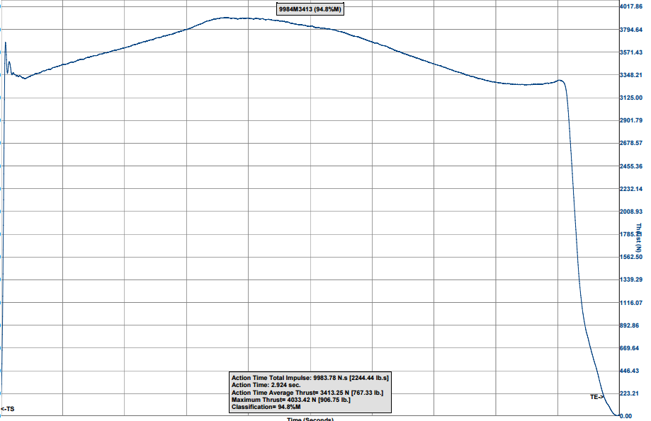
CTI M3400 Published Thrust Curve

Avionics
This section will analyze the performance of the avionics systems against their expected operation.

Pyxida Arming Failure
As part of the nominal arming sequence a command is sent via radio from the ground station to the Pyxida. If this command is nominally received, a confirmation packet is sent to the ground station. During the arming sequence one “ARM” packet was sent from the ground station. This command was not received and no confirmation was sent. The lack of a confirmation packet was not noticed due to operator error. This lead to the Pyxida staying the “Prelaunch” state during the entire flight. This caused the plasma system to not be activated and no pyro events to be commanded by Pyxida.

Pyxida Remote Pyro Command Anomaly
During the flight the ground station operator attempted to manually command main parachute deployment. A “DEPLOY_CH_FIRE” command was sent to the vehicle. This packet was not received or acted upon by the vehicle.

TeleMetrum Telemetry Anomaly
During the avionics arming sequence the TeleMetrum did not communicate with the ground terminal. A single packet was received from another TeleMetrum. Launch pad personnel confirmed that the device was functioning nominally through its beep sequences. The decision was made to fly without redundant telemetry. Post-flight data recovery was successful, with all data downloaded off of local memory. This had no effect on the recovery anomalies. Further experimentation post flight has revealed that the 440Mhz Yagi antenna used during the flight may be defective. Additional points of investigation are the onboard wire antenna, which was re-soldered during avionics hardware integration in early April.

StratoLogger CF-100 Power Loss at Landing
The redundant StratoLogger altimeter successfully commanded drogue and main deployment. The e-match connected to the StratoLogger “main” channel was fired, but did not release the Tender Descender. Post flight data analysis shows the device experienced a power loss during flight. Data indicates this occurred post landing. The StratoLogger also recorded a large pressure spike within 0.07s of the apogee event, likely from the combustion of the drogue recovery charge. This power loss had a negligible effect on the flight. The power loss was most likely caused by a mechanical failure of the linkage between the battery and power terminal of the StratoLogger. Recovery personnel confirmed that the StratoLogger was deactivated when the vehicle was reached. This is consistent with the data.

Recovery
This section will analyze the performance of the recovery systems against their expected operation.

Main Deployment Anomaly
During the flight the 9ft ellipsoidal main parachute failed to deploy. Post flight analysis shows that one e-match fired during flight. This e-match was connected to the StratoLogger. The unfired e-match was tested post flight and found to be functional. It did not fire due to arming issues with the Pyxida. Even though the e-matches fired, the Tender Descenders did not separate. During the construction of Therion the holes in the Tender Descenders for the e-match leads were enlarged to accommodate a different brand of e-match. The Tender Descenders were filled with 4F Black Powder approximately 18 hours before launch. The back side of the e-match lead holes were taped around with duct tape. Post flight testing reveals that in the time between integration and flight, handling of the Tender Descenders caused the black powder to seep through the hole and adhere to the duct tape. By the time of flight there was no appreciable amount of black powder remaining in the Tender Descender. Despite the e-match firing, the Tender Descender did not separate. The following images were taken during post flight testing.
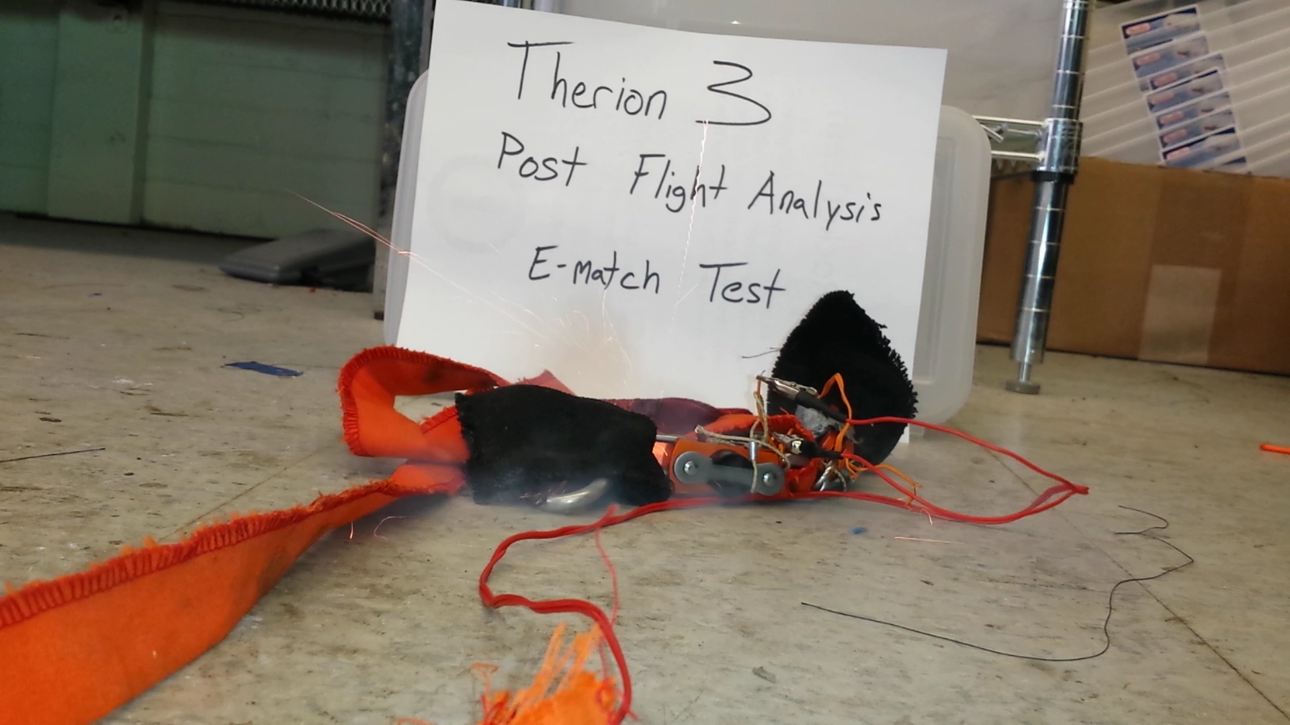
Confirming the viability of the Pyxida e-match
This is an image after the sucessful test fire of the second e-match. This test confirmed that the leaked black powder would not ignite. Note the minimal residue inside the chamber.
Here is the black powder stuck to the duct tape on the back side of the Tender Descender. Some of the black powder near the e-match hole burned, but slowly and the gas did not pressurize the Tender Descender.

Drogue Chute Gore Failure
1.47s after the apogee event, the drogue chute is visible in the zenith camera view. This camera clearly shows two small holes in the parachute. The cause is likely large lateral velocity at apogee causing higher than expected deployment loads. The holes are estimated to have had a negligible impact on descent velocity. The holes had no impact on the main parachute failure. The holes do not appear to propagate during the descent, indicating that the rip-stop nylon performed as expected.
Additional imagery collected post flight shows other smaller holes in the nearby pink gore. The rips in the yellow gore are approximately 6cm and 10cm for the upper and lower tears, respectively.

Drogue Chute Swivel Deformation
Due to slight weather-cocking, the horizontal velocity at apogee was greater than accounted for. This over-stressed and plastically deformed the swivel attaching the drogue to the vehicle. This had no significant effect on vehicle descent dynamics.

Structures
This section will analyze the performance of the vehicle’s structure against its expected operation.

Vehicle Roll Rate
At T+ 00:02.610 the vehicle began rapidly accelerating clockwise around the long axis of the vehicle. As discussed in the payload section, the vehicle retained all its canards at this point in time. This has led to a search for novel mechanisms to explain the acute and drastic shift in roll rate. Prior to the acceleration, the vehicle had a roughly constant roll rate of 72˚/s. From 2.610s to 6.187s the vehicle accelerated logarithmically to 480˚/s. The vehicle maintained this roll rate until T+00:18.550s, at which point the roll rate decelerated. The working theory is that winds aloft were sufficient to reattach flow over the canards unsymmetrically. This theory is corroborated by local geography and NOAA winds aloft measurements. The vehicle was at 291m according to TeleMetrum barometric data when the roll rate increased. Winds aloft were between 35 and 60 knots, using data from the Salt Lake and Grand Junction Airports. Vehicle velocity at that point in time was at 202 m/s vertically. The canards on the plasma section were stalled by 2˚. The winds had the capability to shift the angle of attack by 5.1˚ assuming winds of 30 knots. It is postulated that the vehicle was shielded from these winds by the large bluffs behind the launch site. A single gust of wind could start the vehicle spinning. As the rotational rate increased the relative angle of attack on the canards decreased, creating a feedback loop. This conclusion is counter-intuitive given the loss of a canard, however there are strong indicators that all the canards remained attached for another 21 seconds. It is unknown whether the roll rate affected the structural attachment of the canard that failed at apogee. Further research could be done to ascertain whether the torque expected from an unstalled canard is capable of producing the acceleration seen in the data.

Lithobreaking Exceeded Design Loads
Due to the main parachute deployment failure, the vehicle impacted the desert floor between 27 m/s and 29 m/s. This caused significant structural damage as many parts exceeded their design loads. A non-exhaustive list of failures directly related to the landing follows:
- One fin shattered
- Fin can carbon fiber airframe cracked
- Camera aero shell detached
- Switch band shattered
- Switch band cover detached
- Switch band delaminated
- Avionics bay telescoped into inert section
- Damage to both avionics bulkheads
- Payload structure shattered
- Dented nosecone.
- Plasma canard lost
Most of these components failed acceptably at loads far exceeding their designs. It is worth noting that the avionics bay continues to be a failure point. It is evident that additional structural design and analysis should be invested in the avionics bay. Despite serious damage, the vehicle remained in three major components, with minimal debris. The three sections were: fin can and inert with the avionics bay telescoped inside, the backup recovery bay, and the nosecone.

Payload
This section will analyze the performance of the vehicle’s payload against its expected operation.

Plasma Canard Detachment
During the apogee event a canard is visible in the field of view of both the nadir and zenith cameras. The following image was captured at T+00:24.068 by the zenith facing camera. A piece of white debris has been shed. It is visible for one frame. The debris is on the starboard side of the vehicle.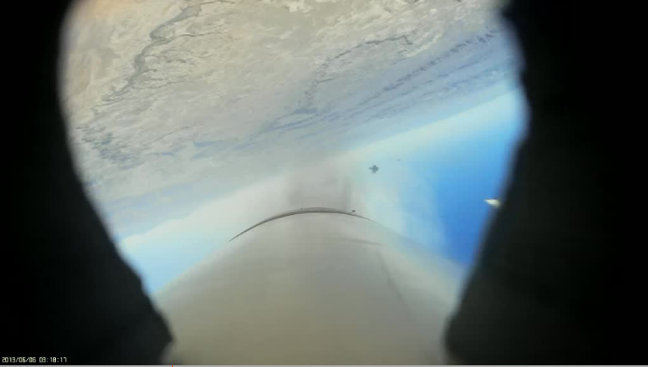
Approximately 0.025s after the debris is visible in the zenith camera, it is visible in the nadir camera for 3 frames. The following image is the clearest image. The attachment structure and airfoil are distinguishable. This leads to the conclusion that this is the missing canard. The reason for the loss of this canard at this moment is unknown.
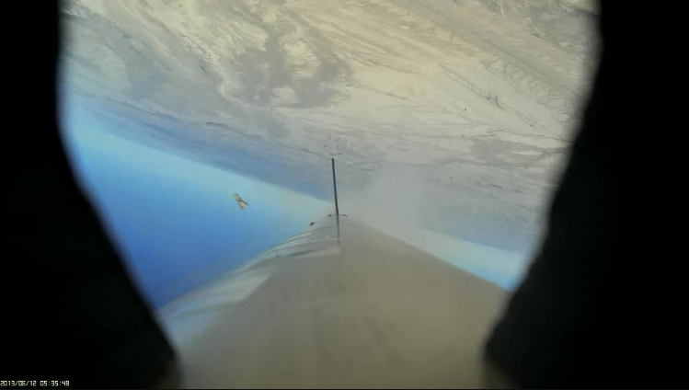
At various points during the descent the nose cone is visible in the zenith camera. It can be confirmed that one, and only one canard was detached at this stage of the flight.

This image was captured at T+ 00:30.553s. A single canard is clearly missing.

OpenCV Data Collection Anomaly
OpenCV was mounted in the nose cone, with no visible way of determining if it was turned on or not. The OpenCV payload operator had tested the distance at which it would be able to be turned on from by the remote. This determined that an effective range for the remote was 30 ft. This test notably occurred while the payload was outside of the vehicle.
After the flight, observers noted that the remote arming device may not have been properly integrated to the payload, or integrated at all. It is the opinion of the payload operator that this was the cause of failure.

Mobius Camera Overheating
Approximately four minutes before launch the radially facing Mobius camera deactivated itself due to overheating. This camera was unique due to its lack of a 3D printed aero shell. This camera was retained by black gaff tape. This combined with the bright sun to create an environment hostile to the camera. The other cameras were in a low infill 3D printed component. This component offered some level of insulation from the sun, keeping them functioning for the duration of the flight.

Lessons Learned
- Run through all checklists cynically, try to misinterpret them or cause them to fail.
- Known bugs in computerized systems need to be well known and their possible failure modes on launch day well understood.
- Test as you fly, and fly as you test. Switching antennas on the TeleMetrum caused unnecessary problems at the launch pad.
- All critical path items should have two sets of eyes on them, and photodocumentation.
- The cost of reputably branded e-matches is small compared to the cost of the rocket.
- The launch environment in Green River is substantially different than that of Berwick or Torrey Farms. This must be accounted for.
- The avionics bay is labor intensive to build and test. It would be beneficial to design it to withstand higher loads due to its valuable data. Particular improvements could be made by switching to all composite construction with stepped composite or aluminum bulkheads.
- A large amount of debris was shed during the apogee event. This crowded the camera view and complicated analysis. Efforts should be undertaken to constrain most debris.

